Summer 1 Weekly Update – 12/05/23
St. Elizabeth’s Catholic Primary
www.st-elizabeths.manchester.sch.uk
T: 0161-437-3890
Twitter: @stelizabethsm22 (639 followers)
Email: admin@st-elizabeths.manchester.sch.uk
Dear Parents/Carers and Children,

I would like to start this week’s update making special reference to last Saturday. Whilst, most of the country were tuning into the Coronation of King Charles III, 25 of our Year 3 children were making their First Holy Communion at St Elizabeth’s Church. It was, like always, a beautiful celebration which I know the children will remember for the rest of their lives. I have enjoyed spending time in Year 3 throughout the week; the children shared how they celebrated this day with their friends and families.

Our school has felt extremely quiet this week as our Year 6 children have been sitting their End of Key Stage 2 assessments. I’m sure you would agree, this is always an incredibly challenging week for the Year 6 children. I would like to say a massive well done to the children for all of their efforts, not just throughout this week, but throughout the entire school year so far. You have always Let Your Light Shine and should be tremendously proud of yourselves.

Last week, the Year 6 staff sent a letter to the children reminding them that although the assessments might tell somebody something; they do not tell them everything. The tests simply do not inform anybody of how wonderful, amazing and unique each and every one of them are. It is the qualities of kindness, forgiveness, compassion, creativity and love that the children demonstrate each and every single day that will stay with them as they grow much older. I encourage every one of our Year 6 children to remember this.

Following all of the hard-work, the Year 6 children were rewarded with a special Post- SATs Celebration Lunch which I’m sure the children will tell you all about when they get home.

This afternoon our Nursery children presented a wonderful assembly celebrating all the fabulous work they’ve done this year. We loved seeing their work, listening to well-known nursery rhymes and celebrating how much they have grown this year in the first year at St Elizabeth’s. Judging by the smiles of the audience we all felt extremely proud of our children.

Have a wonderful weekend,

Miss Simmons

Congratulations to our Gold Award Winners
Congratulations to our Gold Award Winners!

Reflection

In Sunday’s Gospel Jesus tells us that if we love him, we must keep his commandments. And that God loves those who listen to and love his son. Let’s think a bit more about love today.

Christ Jesus,
You came into the world to show us how to live.
May we follow your commandment of love for one another and do what we can to care for all people, especially those who are poor.
Amen

In the Spotlight – Year 5

This half term, Year 5 have been learning about their topic 'Global Warning'. We have looked at the different types of pollution and the impact that this has on the Earth's atmosphere. We also looked at oil spills and the damage this caused to the wildlife and oceans. Then, we even created a leaflet to persuade people to be more conscientious with their waste and how we can be good stewards of the Earth.

Science lessons have been amazing! We have been busy investigating materials and their properties and uses. We worked collaboratively to plan an investigation to test the conductivity of different materials and we are looking forward to putting our plan into practice and finding out which materials are the best conductors and insulators.

In Maths, we have been developing our knowledge of angles and were interested to learn about how to classify them. We started doing a quick recap about acute, obtuse and reflex and angles. After this, we challenged ourselves to use a protractor to accurately measure a series of angles and then looked at how we can measure angles in shapes.

In Literacy we have been looking at balanced arguments. We have created some amazing pieces of work debating the benefits and impact of deforestation, whilst coming to our own conclusions about this. We look forward to writing character descriptions next half term about our class novel 'There's a boy in the girls’ bathroom'.

It's been a truly remarkable last few weeks in Year 5 and the children have shown an increased amount of enthusiasm towards their learning.

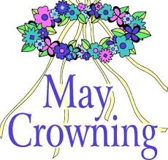
May Crowning

On Wednesday 17th May, we will be crowning Our Lady in song and prayer.

All children are invited to bring a flower to school to place at our Lady’s feet.

Our Year 3 children are invited to bring their Communion outfit to school to change into after lunch.

At 2:15pm, we will gather outside (weather permitting) as our Year 3 children lead the Crowning of Mary. Year 3 parents are invited to join us.

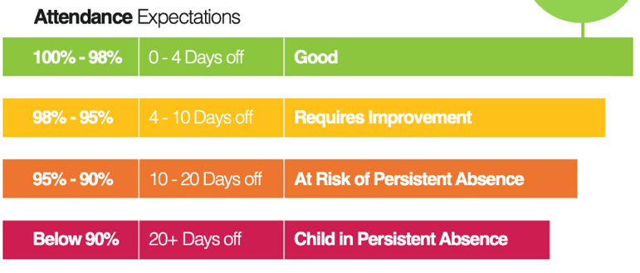

Attendance
Attendance WC 8th May, 2023
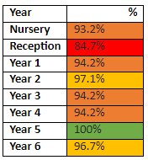

There are 204 pupils with 100% attendance this week. Well done!

Congratulations to Year 6 with best punctuality and to Year 5 with the best attendance this week!

The whole school attendance this week was 94.3%.

We are really excited to inform you that we are now busy planning our Summer Fair which will take place on Friday 7th July, straight after school.

We’ll be collecting different items and holding own clothes days to help collect prizes for our tombola’s. Watch this space!
PTA Update

Dates for your diary:

May

Tuesday 16th – Dental Hygiene Assembly for parents at 2:30pm. All parents welcome

Thursday 18th – Wear it Green Day – Mental Health Awareness Day

Friday 19th – Reception Class Assembly, 9:05am

Friday 19th – School closes at 3pm for half term
June

Monday 5th – School re-opens after half-term.

Friday 9th – Year 3 Class Assembly, 9:05am

Friday 16th – Year 5 Class Assembly, 9:05am

Friday 23rd – Year 3 Retreat Day

Friday 30th – Year 2 Class Assembly, 9:05am

July
Monday 3rd – Year 5 attending St Paul’s Sports Day

Friday 7th – Year 1 Class Assembly, 9:05am

Friday 7th – Summer Fair from 3pm

Wednesday 12th – Year 6 Production

Wednesday 19th – Year 6 Leavers Mass

Friday 21st – Year 6 Assembly, 9:05am

Friday 21st- School Closes for Summer Holidays at 1:15pm

