Spring 1 Weekly Update – 5/05/23
St. Elizabeth’s Catholic Primary
www.st-elizabeths.manchester.sch.uk
T: 0161-437-3890
Twitter: @stelizabethsm22 (637 followers)
Email: admin@st-elizabeths.manchester.sch.uk
Dear Parents/Carers and Children,

This week brought the beginning of May; it has been lovely to see the bright, sunny mornings and evenings which has brought even more smiles to the faces of everybody in school. Following last weekend’s bank holiday, I noticed the children return to school relaxed and refreshed and even more eager to learn.

Throughout the week, our Year 3 children have been working incredibly hard in preparation to receive the Sacrament of the Eucharist. It has been a particular highlight of my week being able to see the children practise for tomorrow’s Mass over at Church; I have no doubt that tomorrow will be a beautiful occasion as always.
Today, members of our Year 5 class attended a special football competition at Manchester United, where they showcased their wondrous football skills and teamwork and really Let their Lights Shine.

This morning, I came in to school and was greeted with a massive array of red, white and blue as the children were excited to celebrate the King’s Coronation. At lunchtime, had our very own Coronation picnic on the school playground and each class throughout the day have been thrilled to complete various tasks and activities to mark this momentous and historic occasion. I’m sure you will all enjoy the special bank holiday celebrations at home. This occasion is a brilliant reminder of the duty and responsibility of our King acting as a true servant to not only this country, but so many nations across the world.

Over the weekend, I would like us all to think about our Year 6 children as they will be sitting their End of Key Stage 2 assessments (SATs) next week. They too have been working extremely hard in preparation; I know they will continue to try their best. Well done for all of your hard work Year 6, you should be immensely proud of yourselves.

Have a wonderful bank holiday weekend,

Mr C. Knight
Acting Deputy Headteacher

Have a wonderful bank holiday weekend,
Miss Simmons

Congratulations to our Gold Award Winners

First Holy Communion

We keep the children in year 3 who are making the sacrament of First Holy Communion in our prayers.

Reflection

Lord Jesus,
Bless the children coming forward to receive Holy Communion for the first time.

May this day be an initial step into life-long love of the Eucharist.

Give them hunger for this sacred food so that they turn to you for comfort, guidance and wisdom as they grow into their full discipleship.

Thank you for their innocence and goodness.

May their hands, extended in anticipation of your Body and Blood, inspire all of us to cherish this sacred sacrament.

Amen

In the Spotlight – Year 4

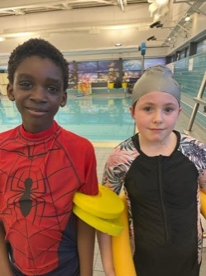
What an exciting and busy half term! It may be a short one, but Year 4 have crammed a lot in! This half term we’ve had our class assembly – where the children re-enacted their part in the prayer relay for their families. In swimming, the children are working really hard to complete their 25 metres unaided, which almost everyone has now achieved. We are so proud of you all!
In Maths, we have been learning about adding fractions, finding equivalents and converting improper and mixed number fractions. We have now moved onto decimals, placing them on a place value chart and number line, and diving them by 10.
Our book this half term in English is ‘Trash’ by Andy Mulligan. From this we have written settings descriptions of a dumpsite and of our own paradise Island. The children have written some fantastic pieces, focussing on expanded noun phrases, similes and metaphors.
Our topic this half term is ‘Picture Our Planet’ where we have been comparing different areas around the world. So far, we have learned about Brazil and its geographical features – not to mention its colourful carnivals! We will later be comparing Brazil to Fiji and Scotland.
In Science, we have been learning about animals including humans, labelling parts of the body and understanding the jobs different organs do in the body.
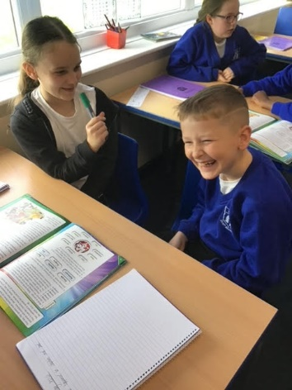
In RE, we have been learning about the early Christians and the first disciples to spread the word of God. We enjoyed acting as news reporters, reporting the story of Stephen where he was stoned to death for his faith.
Well done on a super half term Year 4!

King Charles III Coronation Picnic
Today, we dressed up in red, white and blue to mark the historic occasion of King Charles III coronation tomorrow. We really enjoyed our picnic celebrations and the children had a royally good time dancing. We hope you enjoy watching and celebrating over the weekend with your famillies.

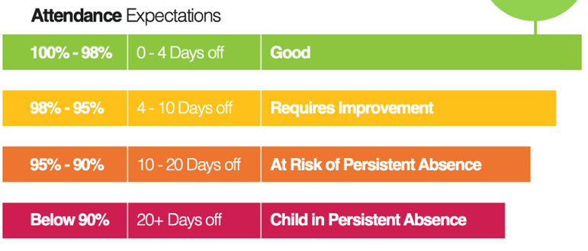
Attendance
Attendance WC 2nd May, 2023
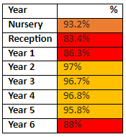

There are 193 pupils with 100% attendance this week. Well done!

Congratulations to Year 2 with best punctuality and to Year 2 with the best attendance this week!

The whole school attendance this week
Was 92.4%.

We are really excited to inform you that we are now busy planning our Summer Fair which will take place on Friday 7th July, straight after school.

We’ll be collecting different items and holding own clothes days to help collect prizes for our tombola’s. Watch this space!
PTA Update

Top Tweets

Please look at the tweets below, they give a great sense of what St. Elizabeth’s is all about! If you don’t already follow us on Twitter you’ll find us at @stelizabethsm22

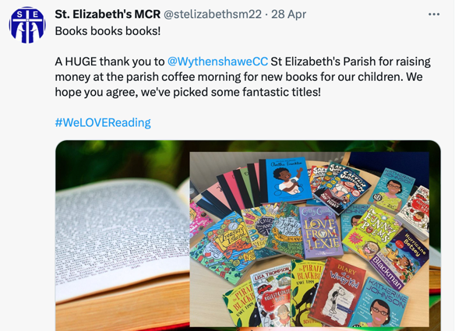

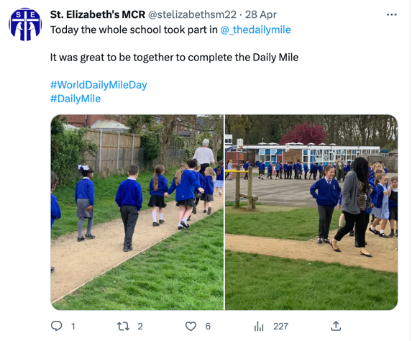
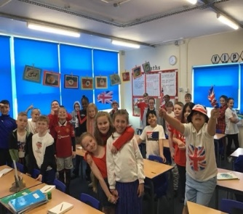
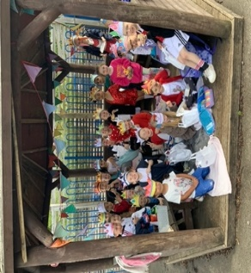
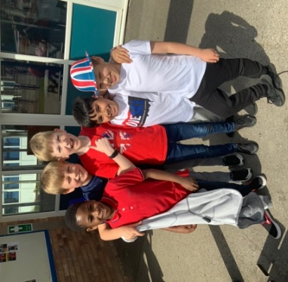
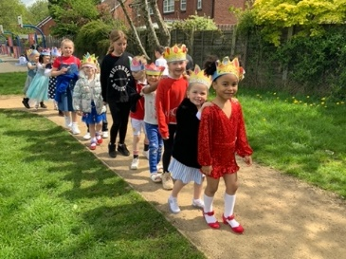

Dates for your diary:

May

Saturday 6th – Year 3 First Holy Communion.
Children, please arrive from 9.20am at church
for the service to begin at 10am.

Monday 8th – Bank Holiday (school closed)

Friday 12th – Nursery Class Assembly (2:15pm)

Friday 19th – Reception Class Assembly, 9:05am

Friday 19th – School closes at 3pm for half term
June

Friday 9th – Year 3 Class Assembly, 9:05am

Friday 16th – Year 5 Class Assembly, 9:05am

Friday 23rd – Year 3 Retreat Day

Friday 30th – Year 2 Class Assembly, 9:05am

July
Monday 3rd – Year 5 attending St Paul’s Sports Day

Friday 7th – Year 1 Class Assembly, 9:05am

Friday 7th – Summer Fair from 3pm

Wednesday 12th – Year 6 Production

Wednesday 19th – Year 2 Leavers Mass

Friday 21st – Year 6 Assembly, 9:05am

Friday 21st- School Closes for Summer Holidays at 1:15pm

