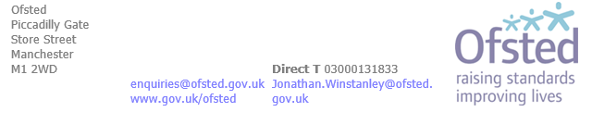
17 January 2023

Dear parent or carer
Inspection of St Elizabeth's Catholic Primary School by Ofsted
We have just told your child's school that we will inspect it on 18 January 2023. The lead inspector will be Sarah Barraclough, HMI. We are writing to you because we would like to know what you think about the school. Please take a few minutes to read the leaflet that came with this letter. It explains why we inspect schools and what happens during an inspection.
Your views about the school are important to us
If you are a registered parent or carer of a pupil at the school (including pupils on sick leave or who are temporarily excluded), you can tell us your views about the school by completing Ofsted's online survey, Ofsted Parent View, at: https://parentview.ofsted.gov.uk.
Ofsted Parent View asks for your opinion on some aspects of your child's school, including the progress made by your child, the quality of teaching, how the school deals with bullying and poor behaviour. It also provides a free-text box for you to make additional comments, if you wish. The inspectors will use the online survey responses when inspecting your child's school. Written comments can also be sent to the school in a sealed envelope, marked confidential and addressed to the inspection team.
To register your views, you will need to provide your email address, which will be held securely. It will not be used for any purpose other than providing access to the online survey. Neither schools nor Ofsted will have access to any email addresses.
Please complete the online survey by 11am on 18 January 2023 as this will give the inspection team more time to consider your views. However, we will consider all online responses that are completed during the inspection, although the free-text box facility will not be available after noon on 19 January 2023.
Speaking to an inspector
If you are unable to complete the online survey, it may be possible to speak to an inspector during the inspection, for instance at the start of the school day, or to pass on messages to the inspectors if you are unable to speak to them in person. Inspection administrators will be happy to make the necessary arrangements. If concerns are raised about child protection, we may have to pass the information we receive to social services or the police.

You can contact the administrators on 03000131833. Inspectors will be pleased to receive your comments, but cannot deal with complaints about individual pupils or settle disputes between you and the school.

Gathering personal information on inspection

Inspectors will gather any personal information necessary to assist them in inspecting a school. Our privacy policy sets out what personal information we collect, what we do with it, how long we keep it and individuals' rights under data protection legislation. The contact details for Ofsted's Data Protection Officer are: Email - informationrequest@ofsted.gov.uk; Post - Information management team, Ofsted, 2 Rivergate, Temple Quay, Bristol, BS1 6EH.
Thank you in advance for taking the time to complete the online survey.
Yours faithfully
Jon Winstanley
Inspection support administrator

.

