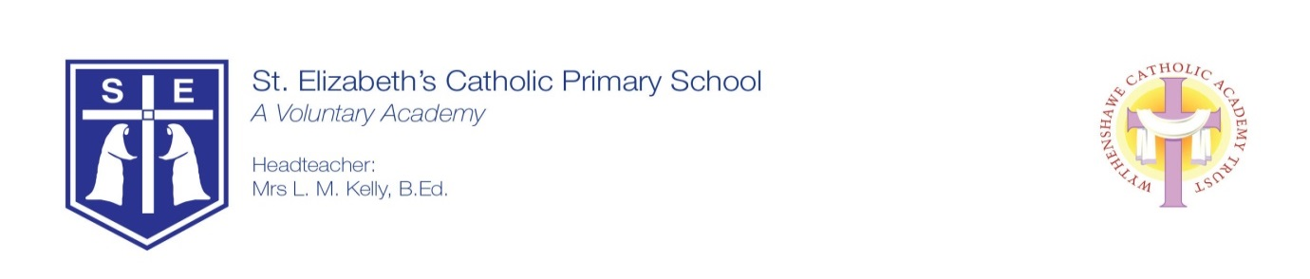
10th July 2020

Dear Parent and Carers,
I am writing to let you know of our plans for September 2020. As you may be aware, we have had some guidance from the government about re-opening to all children from September. This was published last Thursday and we have been studying this information since then.
We have re-examined our risk assessments to ensure that we have everything that we can, in place ready for welcoming the children back into school.
We have been informed that we will get an update to this guidance mid-August and therefore, at this point, we will need to re-evaluate our planning and risk assessments before we are able to open school and welcome everyone back.
To enable this to happen we will be undertaking an ‘Extra-ordinary INSET Day’ for staff on Wednesday 2nd September 2020. This will mean that school will be closed to children on this day. We will therefore begin our re-opening to children from Thursday 3rd September. A further INSET day will be taken later in the school year to enable our planned school priorities and training to take place.
Year 6, Year 4 and Year 2 children will come to school on Thursday 3rd September. Year 5, Year 3, Year 1 and Reception children will come to school on Friday 4th September. All children will return to school on Monday 7th September. We will contact you nearer to September with details of school timings. We will aim to give you as much notice as possible once this is planned. Nursery teachers will contact all parents of Nursery children to confirm a start date. Unfortunately, we are unable to have a Breakfast Club at this time.
Thank you for your understanding in these unprecedented times.
Yours sincerely
Mrs L. Kelly
Headteacher

