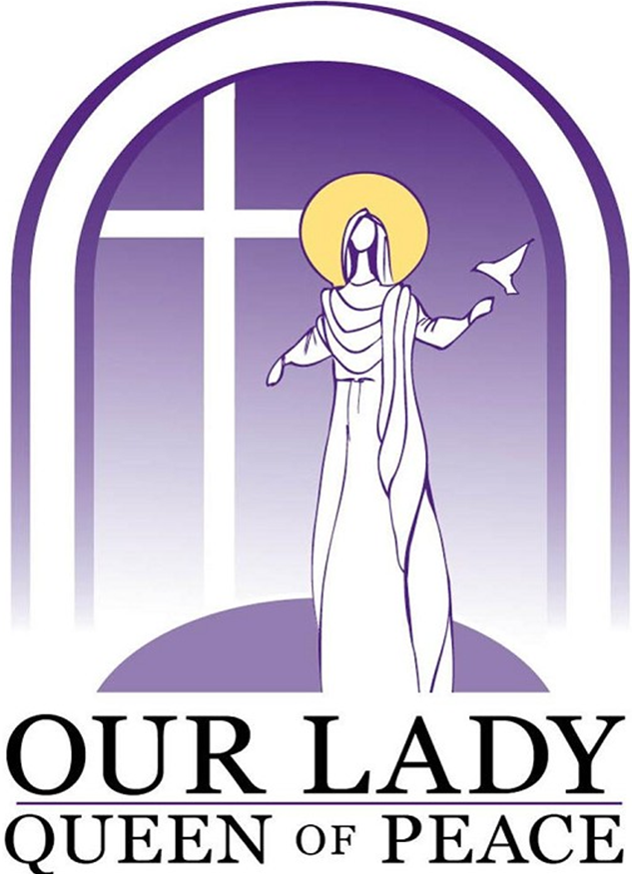

Wythenshawe Catholic Team Ministry
Parish of Our Lady Queen of Peace

Parish Priest: Fr Nick Kern
Assistant Priests:
Fr Michael Coughlan
Fr Thaddeus Opara
Sacred Heart & St Peter’s presbytery
Floatshall road
Baguley
Manchester M22 1HP
Tel.: 0161 998 5319
E-mail: parishpriest298@btinternet.com
16th December 2018

To all parents at St Elizabeth’s Catholic Primary School

As the Christmas holidays are approaching and the end of another school term is in sight we would like to take this opportunity to thank you for all that you continue to do for our School and Parish.

Over these past few weeks we have been delighted to watch many of your children in their various performances, which help us to reflect on the true meaning of Advent as we prepare to celebrate the birth of our saviour at Christmas. On the back of this letter we have included all the times of all our Christmas Masses. In particular, we would like to invite you and your children to Carols in Peel Hall Park at 4pm on Saturday 22nd December & the Christmas Vigil Mass at 5pm on Christmas Eve in St Anthony’s church. We look forward to seeing many of you there as we celebrate together the great feast of our Saviour’s birth.

Please do not hesitate to contact one of us if you need anything at all. With every blessing for a very happy and holy Christmas.

Fr Nick, Fr Michael & Fr Thaddeus

Catholic Church in Wythenshawe

2018 Christmas Masses

Christmas Eve Night Monday 24th December
Children’s Christmas Masses | Christmas Night Mass
5.00pm at  St Anthony’s, Woodhouse Park  Sacred Heart & St Peter’s, Baguley  St Hilda’s, Northenden | 9.00pm at  St Aidan’s, Northern Moor  Midnight at  St Anthony’s, Woodhouse Park  (with the Readings of  Midnight Mass)

Christmas Night Monday 24th December
Syro-Malabar | 8.00pm | St Anthony’s
Knanaya | 8.00pm | St Elizabeth’s
Syro-Malankara | 9.00pm | St Hilda’s

Christmas Day Tuesday 25th December
9:30am | St Hilda’s, Northenden
9:30am | St Elizabeth’s, Peel Hall
10am | St Anthony’s, Woodhouse Park
11am | Sacred Heart & St Peter’s, Baguley
11am | St Aidan’s, Northern Moor
11:30am | St Luke’s, Benchill

Please come along & join us in the celebration
of the birth of Jesus this Christmas!

